SIGNAGE OPPORTUNITIES - 2021 NATIONAL MEDICARE SUPPLEMENT SUMMIT
September 8-10, 2021 Schaumburg (Chicago) IL

We are pleased to offer the following opportunities for additional signage at the 2021 Summit.
EXCLUSIVELY AVAILABLE to Conference Sponsors. Everything is FIRST COME!

Questions: Call Jesse Slome, AAMSI, 818-597-3205
To Order Signage: SUBMIT THE ATTACHED RESERVATION FORMS to SourceOne (Pages 3 & 4)
Payment form MUST BE PROVIDED to secure your order. Artwork due August 18, 2021. See payment form for cancellation charges.
_________________________________________________________________________________________________________
CLASSROOM DOOR SIGNS - outside doorways to the largest
session room + meal room. Schaumburg East and Schaumburg West.
Up Wednesday (Agent Free Day), Thursday & Friday (thru Noon)
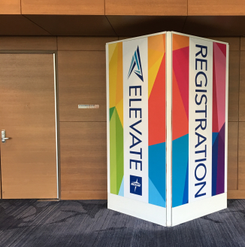

Total Number Available: Four (4)
Size: 3 feet wide x 7 feet tall.

Offered first to DIAMOND SPONSORS. Limit: 1-per sponsor.
If all 4 Classroom Door Signs are NOT reserved by June 1, we will
make them available to Platinum level sponsors.
Cost-per Classroom Door Sign: $950 Each
_________________________________________________________________________________________________________

HALLWAY METER BOARDS - displayed along the hallway leading
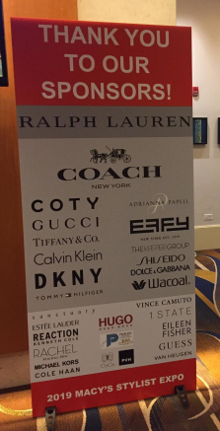
from the Renaissance Hotel to the session rooms and toward the exhibit hall.
Up Wednesday (Agent Free Day), Thursday & IF possible Friday (thru Noon)
Number Available: 27
Size: 3-feet wide x 7-feet tall (36" x 84")
Printed both sides, includes hoofer feet.

Maximum of 3 boards per-sponsor

Cost-per Hallway Meter Board display: $750 Each
_________________________________________________________________________________________________________

FLOOR DECALS - applied to the carpet along the hallway leading
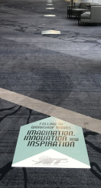
from the Renaissance Hotel to the session rooms and toward the exhibit hall.
Up Wednesday (Agent Free Day), Thursday

Number Available: 36
Size: 3-feet long x 2-feet wide less the arrow area.

Maximum of 3 floor signs per-sponsor

Cost-per Floor Decal: $125 each floor decal
_________________________________________________________________________________________________________
STAIRCASE LOGOS - applied to the main staircase leading up to
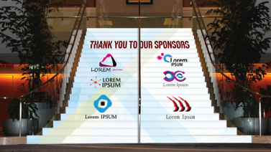
break out rooms from the Renaissance Hotel.
Up Wednesday (Agent Free Day), Thursday & Friday (thru Noon)
Total Number Available: 6
Size: 3 steps on one side (about 30" x 30")

Cost-per Staircase Logo:
$950 a 3-step section (example shown above)
or $5,500 for whole staircase

The 2021 Medicare Supplement Industry Summit
September 8-10, 2021 Renaissance Hotel & Convention Center, Schaumburg, IL

EVENT SIGNAGE COMMITMENT FORM

Return this form + the payment form to: Cara Pajian
Email: Cara@SourceOneEvents.com Fax: 708-344-3050
Date: _____________________

We request and agree to pay for the following:
Number of Classroom Door Signs: ________ Limit 1 per DIAMOND Sponsor @ $950-each

Number of Hallway Meter Boards: ________ Limit 3 per-Sponsor @ $750-each
Number of Floor Decals: ________ Limit 3 per-Sponsor @ $125-each

Number of Staircase Logos: ________ @ $950-per-3-step section

NOTE: Placement will be random with signs interspersed. Pricing reflects all production, placement and removal costs. Artwork is the responsibility of the sponsor. Payment will be processed once approved by the Association. Artwork MUST BE PROVIDED by August 18, 2021 or your order will be cancelled. A refund less an administrative charge of between 50 and 100% will be applied.

______________________________________________________________________________________________________________________________________________________________________________________________________________________________________________________________________________________________________________________________

CONTACT INFORMATION
Company Name ________________________________

Contact Name ________________________________
Phone ________________________________

E-mail Address ________________________________

______________________________________________________________________________________________________________________________________________________________________________________________________________________________________________________________________________________________________________________________

Artwork is due to SourceOne by August 18, 2021.

Charge Authorization
www.sourceoneevents.com

Show Name  The 2021 Medicare Supplement Industry Summit | Booth Number | Date

Charge Authorization - Payment Policy

Payment for Services – SourceOne requires full payment prior to the time services are ordered. SourceOne requires a credit card authorization with order.

Method of Payment Onsite – SourceOne Events, Inc. accepts MasterCard, VISA, Discover, American Express and cash. We do not accept purchase orders as forms of payments. All payments are to be made in U.S. funds drawn on a U.S. Bank.

Third Party Billing – SourceOne requires that the exhibiting firm is responsible for all charges incurred on its behalf. If third party does not pay for services SourceOne reserves the right to collect full payment from exhibitor.

Cancellation of Order – Orders cancelled by the Exhibitor or due to the cancellation of the event or non-participation may be subject to a cancellation fees equal to 50%-100% of the total order, based on the status of the move-in, work performed and SourceOne setup costs or expenses.

Amount Due | $
Charge my credit card in the amount of | $

Method of Payment

MasterCard VISA Discover American Express Corporate Card Personal Card

Account #: - - -
CVV2 (also known as CVC2 or CID) is a three or four digit value that is uniquely derived for each credit card account. On Visa and MasterCard cards, it is a three digit value printed in reverse italic characters on the signature panel following the last 4 digits of the account number. On American Express cards, it is a four digit value printed on the front of the card, usually on the right side. In a card-not-present environment such as the Fax or Internet, CVV2 lets a merchant verify that the cardholder does in fact have the card in his or her possession.

Exp. Date: / CVV2 number:

Cardholder Payment Information

Cardholder’s Name (Please Print) | Email Address (If Different Than Below)
Cardholder’s Billing Address (Please Print) (Street) (P.O. Box) | City |  | State | Zip/Postal Code
Cardholder’s Phone (If Different Than Below) Ext.: | Cardholder’s Fax (If Different Than Below)
Authorization Signature | Authorized By – Please Print | Date

Payment Information (If Different Than Cardholder Info)

Company Name | Email Address |  | Booth Number
Address (Street) (P.O. Box) | City | State | Zip/Postal Code
Phone Ext.: | Fax
Authorization Signature | Authorized By – Please Print |  |  | Date

Please Note: By signing, I agree to all terms and conditions of the contract. I authorize services to be charged to this card for this event only.

